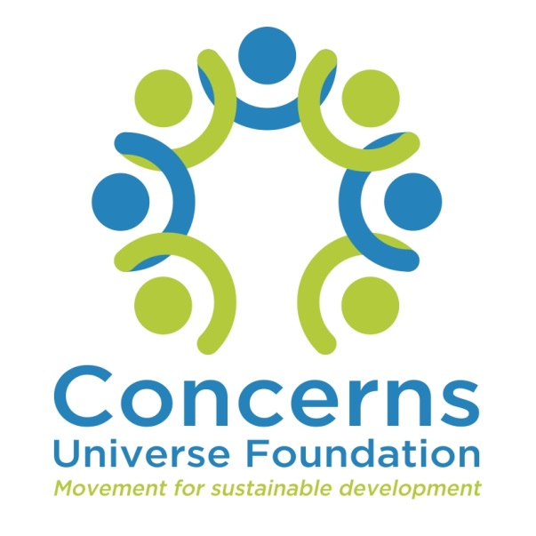
Annual Activity Report April 2019 - March 2020

Contents

Introduction 3
Child Development Centres 4
Community College 7
Community Health and Development Program 10

INTRODUCTION
Concerns Universe Foundation (Concerns) was founded in 2001 by like-minded people with a passion to help underprivileged communities. Since then, Concerns have helped people reach their full potential by creating opportunities to lift themselves and their future generations out of poverty. Concerns began with one early childhood care and development centre in the Jeevanahalli slum and have now expanded to four child development centres, two tuition centres, an education sponsorship programs for school children, a community college and a community based and driven health and development program.
Concerns began with the desire to address the need for quality Early Childhood Care and Education (ECCE) in poor communities located in Bangalore East. Along with ECCE, Concerns started a health and development program for the communities which continue until now. During community visits, staff identified the need to educate and skill married women and dropouts this led to the start of the community college, students who enrol get a certificate or a diploma qualification on completion which increases their ability to get employed and support themselves and their families.

OUR PHILOSOPHY

Our philosophy is to empower and transform individuals and work towards sustainable development in society.

OUR BELIEF

Concerns Universe Foundation believes that every individual has the potential to improve their own life and become both economically independent and socially dignified.

OUR VISION

We envision a community where everyone can achieve their educational, economic and social goals.

OUR MISSION

To realise this vision, Concerns works with urban poor communities and provides opportunities for education through child development centres, vocational training to enhance employability, improve economic status and promote the adoption of a healthy lifestyle.

OBJECTIVES
- To help the community to understand the importance of education and to prepare the children of the community to enter formal schools and perform better academically.
- “Prevention is better than cure”. To work with children and adults to give them the information and education needed to prevent illness and death.
- To help women develop outside the domestic environment by training them in health, nutrition, computers, life and other skills to make them more independent and dignified.

CONCERNS CHILD DEVELOPMENT CENTRES

Activities during the academic year 2019-2020:
- Teachers decorated the centres to create a welcoming atmosphere, these decorations were in the form charts containing the children’s names and birthdays, colour and shape concept materials, alphabets, numbers, daily time table, and monthly programs.
- All children received a set of six books, which were: an alphabet writing book, number writing book, picture reading book, drawing book, colouring book, and alphabet reading book.
- All the child development centres observed national holidays and celebrated festivals.
- Monthly parents meetings were organized on the following topics:

Month | Topic
June 2019 | Mothers were given a brief introduction about the services offered by Concerns
July 2019 | Parents were briefed about the importance of nutrition and the consequences of malnutrition in children
August 2019 | Awareness session on Dengue fever
September 2019 | Demonstration of HPM (High protein mix) powder
October 2019 | Informative session about anaemia
November 2019 | Childhood injury prevention
December 2019 | Child rights and responsibility
January 2020 | Home remedies

- Dr Eileen conducted bi- annual health check-ups in all the child development centres. During the first check-up, she noted various health issues in children like – underweight, stunt growth, ear wax, dental carries, malnourishment, Vitamin D deficiency among other issues. During the second check-up, the health status of all the children was followed up.
- The children’s assessment was conducted twice a year. Height and weight measurements were taken by the teachers in their respective centres. The height & weight percentile were recorded through the growth chart. During the first round of assessment, a pre-test assessment was also conducted for all the children to evaluate their language skills, cognitive skills, fine & gross motor skills and their general aptitude.
- The following supplements were given to the children-
- Vitamin A – 2 doses (Vitamin A is essential to support rapid growth and it helps to combat infections.)
- Polio drops- 2 doses
- SBG drops – 1 dose
- Albendezole – 2 doses (Albendezole is used to treat certain infections caused by worms).
- To ensure proper nutrition for the children, children received one wholesome and nutritious meal prepared at the centres and to monitor the nutrition they receive at home, children carried one meal from home.
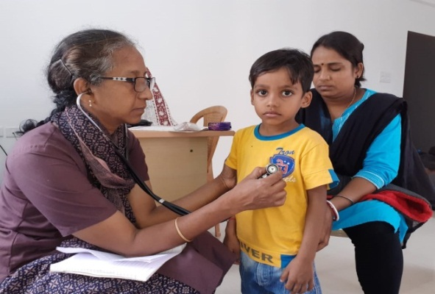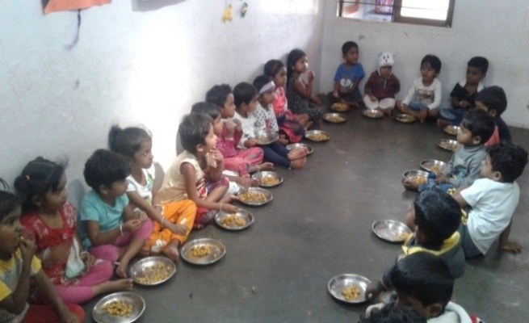
Children enjoying their nutritious meal
Health check-up by Dr Eileen

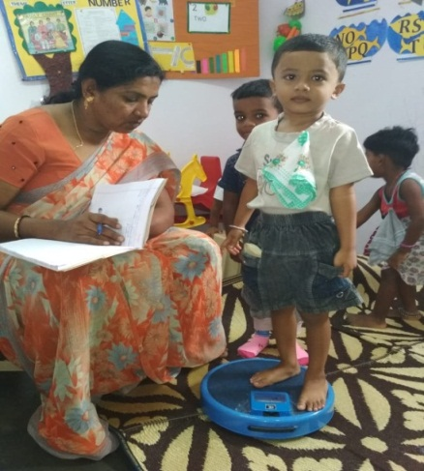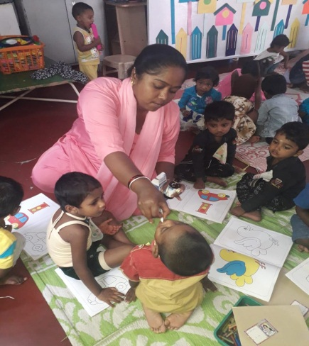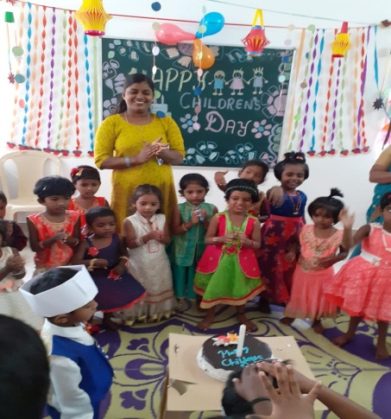
Albendezole and Vitamin A supplements administered by the Primary Health Centre Team

Children’s day celebrations
Childcare staff recording the height and weight measurements

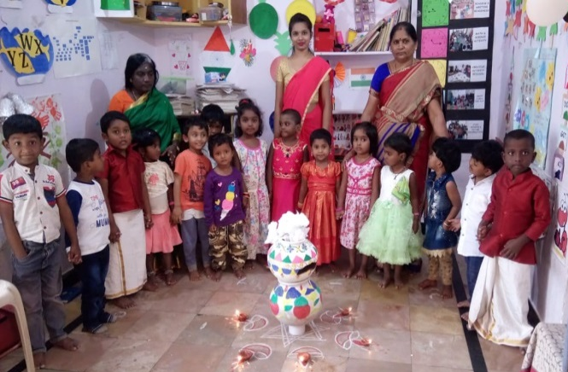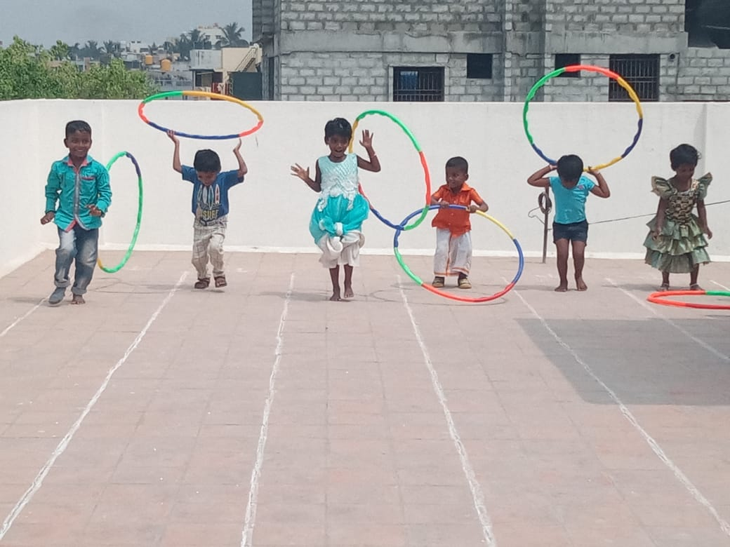
Children participating in sports day
Pongal Celebration

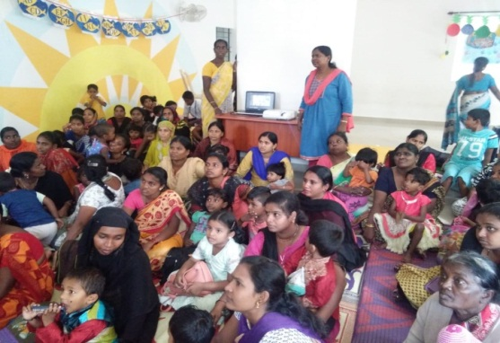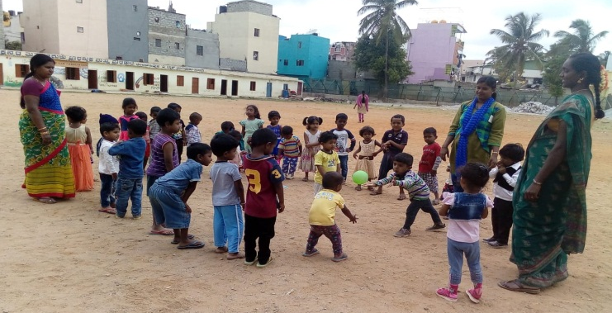
Free outdoor play session
Parents Meeting

CHILD DEVELOPMENT CENTRE CASE STUDIES
- Mary (Concerns Child Development Centre)

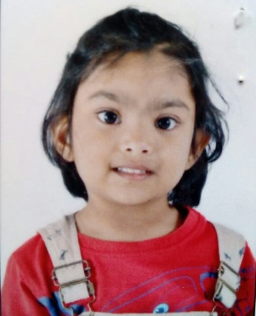
Mary is a five-year-old child who completed her preschool education at Concerns Child Development Centre. While only a month old, she underwent a head and neck surgery, due to which she had delayed speech and locomotor difficulty (her walking is affected). Initially, she joined the Anganwadi centre near her house, but her parents were not satisfied with the centre. They admitted Mary to Concerns Child Development Centre since her elder brother had also attended Concerns Child Development Centre. Since then, her speech and locomotor ability have improved. She actively participates in activities conducted in the centre and can share her experiences with her parents. Mary’s parents are happy to see her improvement.

- Ethan (Concerns Child Development Centre)
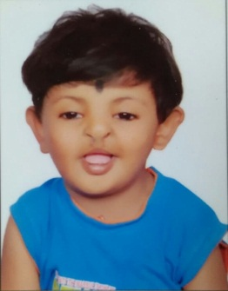
Ethan is a four-year-old child with a cleft palate. The doctor visiting the centre has recommended surgery when he is ten years old to help him improve his communication (pronunciations) and facial features. Since his older sister completed her preschool education from Concerns Child Development Centre, his parents wanted Ethan to join the same centre. Initially, he was hyperactive and wouldn't participate in activities conducted at the centre, but the teachers supported him and gave him time to adjust to the childcare environment. He also had difficulty in conversing since he had a cleft palate. With the constant support and encouragement of his teachers, Ethan is now well-adjusted to the childcare environment. He now recites rhymes, names the colours and eats on his own. Though he still has pronunciation difficulties, he tries his best to communicate. He shares a special bond with the teachers, who have supported him. Ethan also has a younger sister with a cleft palate. His parents are happy with his progress and plan to keep him for another year in Concerns Child Development Centre as well as admit his younger sister in the centre.

CONCERNS COMMUNITY COLLEGE
Concerns Community College recognizes that every individual has the potential to improve their own life to become economically independent and socially dignified and therefore provides opportunities for the disadvantaged to enhance their knowledge and skills thereby increasing their employment opportunities.

OTHER SUBJECTS INCLUDED-
- Functional English
- Life-Coping Skills
- Interpersonal Relationships Skills
- Community Health
- Basic Computer applications

The Concerns Community College faculty motivated the students to pursue their higher education. As a result, 4 girls joined Secondary level and 7 girls enrolled for Senior Secondary level in the National Institute of Open Schooling (NIOS).

- JOB PLACEMENT DETAILS - Batch of 2018-2019
Name of the Course | No. of Students | Employed | Higher Education
Early Childhood Care and Education | 17 | 13 | 4
Office Management | 11 | 6 | 5
Beauty Culture & Hair Care | 6 | 6
Vertical Mobility | 12 | - | 12

ACTIVITIES CONDUCTED IN COMMUNITY COLLEGE THROUGH THE ACADEMIC YEAR 2019-2020

- The year began with the inauguration of the academic year along with talents day for the students.
- Students attended a special session on “Success in life” conducted by Mr Alwyn from Toast Masters, Dubai.
- The students had the opportunity to visit the LinkedIn office in Bangalore to attend a workshop on Interview Skills.
- Students participated in workshops on Communication and Leadership Skills conducted by Mrs Lucina. These sessions included many creative and interactive exercises.
- A special session on teamwork and character building was held for the students.
- 25 students appeared for the National Skill Development Corporation (NSDC) exam for the Documentation Assistant trade under the Logistics Sector Skill Council. To prepare for the exam, a mock interview was held in January 2020. The final exam was conducted in February 2020, and 22 out of 25 students passed.
- As part of an exposure visit, students visited six health institutions in Bangalore, like NIMHANS and Rajiv Gandhi Institute of Chest Diseases to learn about preventive measures, hospital set-up and functioning. In all six hospitals, each student got an opportunity to meet a patient and their attender.
- Students conducted health awareness sessions in the community on respiratory infections, measles and hepatitis B. They prepared forty nutritious dishes, using low cost and locally available ingredients, for display in the community.
- The students of the Beauty Culture and Hair Care specialization (BCHC) had bridal make-up classes as part of their practical classes.
- The BCHC students interned for three months, from December 2019 until February 2020, in local parlours to gain on the job experience.
- Faculty members conducted counselling sessions for all the community college students.
- Students of the Early Childhood Care and Education specialization (ECCE), interned in local schools for a total of four weeks throughout the year.
- As part of practical classes, ECCE students organised a parent’s meet for the Child Development Centre mothers on balanced meal plans for their children, they also went on observational visits to the Child Development Centres and organised Independence Day and Children’s Day celebrations for the children.
- A canteen facility was started for the students.
- Students celebrated Christmas and Women’s Day during the academic year.
- Sports Day was organised for the college students and they eagerly participated and enjoyed themselves.
- As part of a field trip, students were taken to various important sites in Bangalore, including Vidhana Soudha, High Court, General Post Office and the Metro Station.

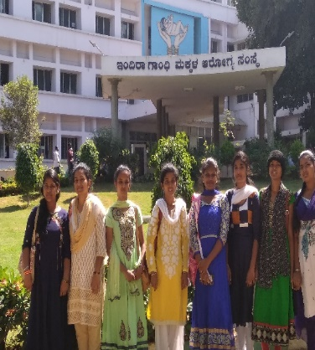
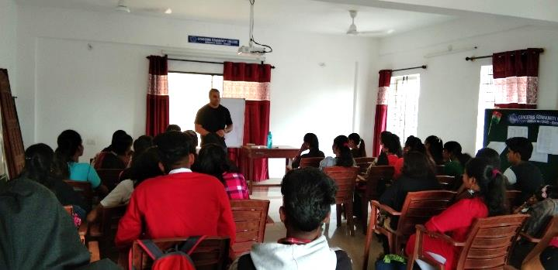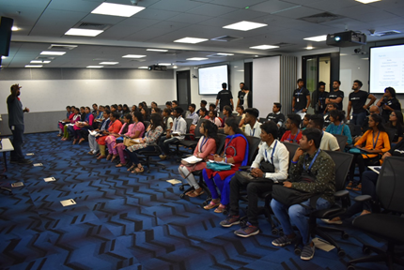
Visit to health institutions
Session on “Success in Life”
Students at the LinkedIn Office

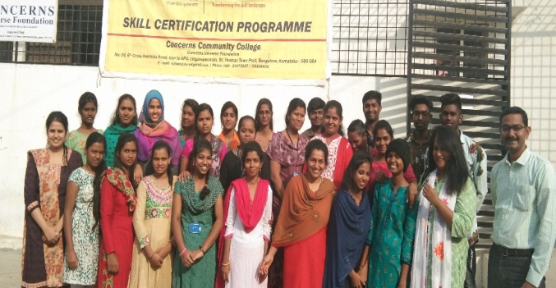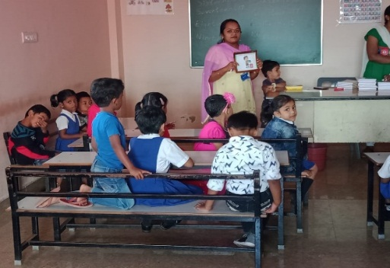
Students after attending the NSDC exam
An ECCE student during their internship
COMMUNITY COLLEGE CASE STUDIES
- Sunitha Nicholas (Concerns Community College ECCE 2018- 2019 Batch)

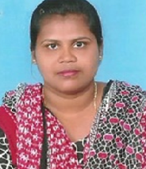
Sunitha Nicholas is a 31-year-old married woman with two children. Her childhood was not happy as she grew up without a mother and had an alcoholic father. She had studied only up to 10th standard then worked as a maid to support her family. Our community health team visited her and motivated her to join Concerns Community College. It was a real struggle for her to leave her job and study, but with her husband’s support, she joined the Early Childhood Care and Education training offered at Concerns Community College. It was a challenge for her to study after a long break. But she took it up despite all her struggles and balanced her education and home life. She was also encouraged to complete her 12th standard through NIOS – open schooling. Initially, she found it very difficult to cope but with her hard work, strong determination and perseverance, she completed her training and got a job in Diya Ghar School and is currently earning Rs. 15000/- per month.

- Krishna (Concerns Community College Vertical Mobility 2018 – 2019 Batch)

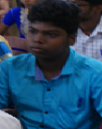
Krishna is a 16-year-old boy who failed the 10th standard. His father works as a security guard in a school while his mother works as a housemaid. His failure brought grief to the family as he was the first generation child to attend school. His parents enrolled him in the Vertical mobility course of Concerns Community College. Krishna was a shy boy and didn’t show much interest in anything. He also felt guilt for not studying well. The coaching classes in Math and Hindi helped him. The life coping and interpersonal skills taught at college helped him overcome all his negative feelings. Krishna started actively participating in college activities and motivated other students to study. He also completed learning basic computers. His teachers prepared him well for his supplementary exams, which he wrote and passed. He has now joined a college to pursue his pre-university course.

- Shashikala (Concerns Community College Beauty Culture and Hair Care 2018 – 2019 Batch)
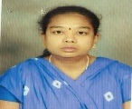
Shashikala is a 23-year-old girl who studied till 7th standard in a Kannada medium school. Her mother works as a housemaid her father has passed away. Due to their poverty, Shashikala had to discontinue her studies and take care of household chores. She joined Concerns Community College for the Beauty Culture and Hair Care course since she could not read and write. The college encouraged and motivated her to learn English and basic computers. It was a real challenge for teachers to translate every class for Shashikala to understand, but now she has learned to speak English and can read and write. Currently, she is providing beauty services at home and earning Rs. 6000/- per month.

CONCERNS COMMUNITY HEALTH AND DEVELOPMENT
- HEALTH CHECK UP
Doctor Eileen conducted health check-ups for all the children across the four centres and the students of community college.
In the child development centres:
24 children were underweight; 11 malnourished; 15 stunted (lower height for age) ; 6 wasted (lower weight for height) Additional nutrition was given for all the children and 80 % improved in health and gained weight. All the children were given deworming tablets, Vitamin A tablets, Polio drops and SBG drops.

The community college students were also given deworming tablets. Some of the students were prescribed other medications and referred to other hospitals for further treatment.

- PROGRAMS FOR CHILDREN AND YOUTH
- AFTER SCHOOL COACHING
To improve the academic performance among the children of the community, after school coaching classes were conducted in three community centres. Children showed much improvement in their school work and attendance. Twice a month, health classes were conducted to improve personal hygiene and health care among the children. During 2019-2020, 65 children attended the classes, 25 children in Janakiram layout, 21 children in M.V garden, Ulsoor and 19 children in Gajendra Nagar, Baiyappanahalli.

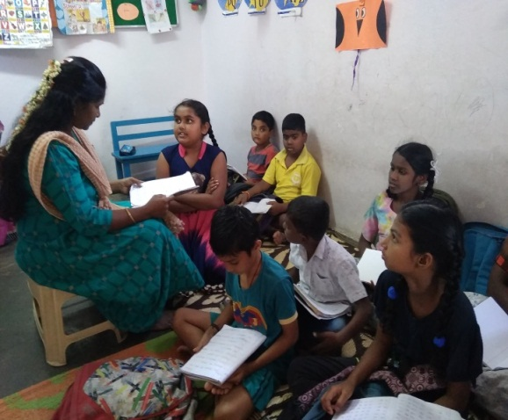
Students attending after school coaching class in the Gajendra Nagar centre

- EDUCATION SPONSORSHIP PROGRAM
Partial financial support was provided for 45 school going students in the community.

- BACK TO SCHOOL PROGRAM
This program encourages school dropouts to continue their education and discourages child labour. Currently, there are 64 children enrolled in this program, the team is following up with 45 students and 7 students have re-joined school.

- SPORTS
15 children from the community were given the opportunity to be trained in athletics and participate in the Inter-NGO Sports conducted by Concerns India Foundation and Bangalore Sports Club Athletic Academy.

- SUMMER PROGRAMS
SUMMER CAMP
A summer camp was conducted for 5 days in the Janakiram Layout and Ulsoor communities. Various activities and a rally to create awareness about health and education were conducted.151 children attended the camp.

SUMMER COMPUTER AND BOOT CAMP
During the month of April and May 2019, 57 students from the community enrolled to learn basic computer skills. All the students independently engaged in online computer practical sessions.
- COMMUNITY COMPUTER CLASSES
- 10 women and men from the community learnt Introduction to Computers and Basic computers. All the students received practical training in using computers and computer applications.

- COMMUNITY HEALTH AND DEVELOPMENT PROGRAM
- 26 health awareness sessions were conducted in the communities, for BBMP employees, government tailoring units, CUF after school coaching classes and child care centres, and community women and men on preventative medicine.
- 1733 new contacts were made in the community. Community members interacted well with the CUF team and have found appropriate ways to handles issues, share information and help each other. They choose and utilize the resources and facilities in the community appropriately.
- 2,113 individual visits were made based on the needs of the community members, to create health awareness and give appropriate advice.
- 305 women’s health education sessions were conducted to improve eating, health and hygiene habits among the women of the community. Intake of nutritious food has increased and women are able to treat minor health issues using home remedies.
- 34 tuberculosis patients from the community completed their treatment through PHC and regular follow ups were done for 32 members by Concerns.
- 8 parent education sessions were conducted for parents of child development centre students to teach them about healthy practices like preparing low cost nutritious meals and home remedies for minor ailments.
- 2,124 community members benefitted from referral services with regard to joining school, medical assistance, trainings and job placements.

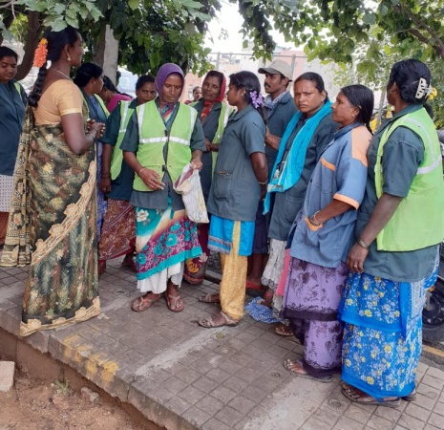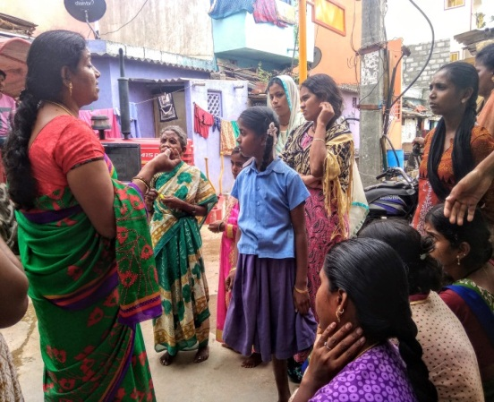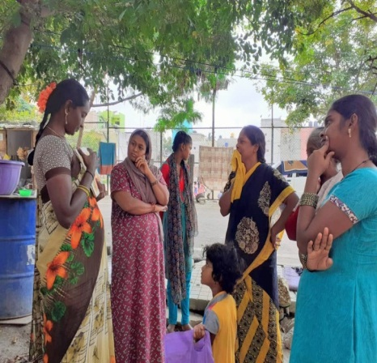
Community health awareness sessions

- WOMEN AND CHILDREN’S HEALTH PROGRAM
- 194 pregnant women were referred and availed antenatal care. They were advised on low cost nutritious food, healthy diet, regular check-ups, simple exercises, and food taboos.
- 230 mothers were referred and availed post-natal care. They were advised on low cost nutritious food, healthy diet, simple exercises, food taboos, and feeding.
- 194 mothers were referred and availed immunization services for their children.

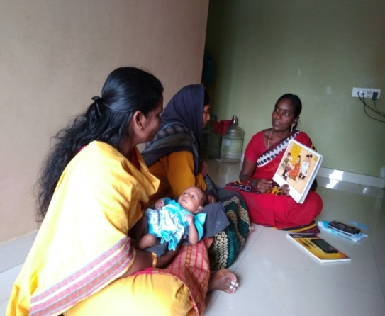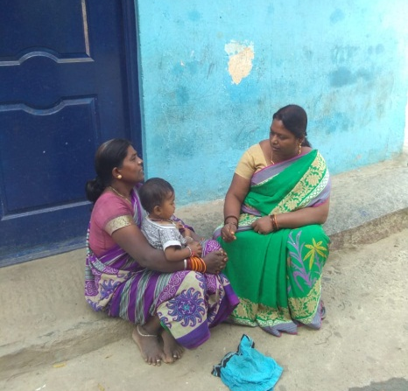
Post natal care sessions for mothers in the community

- COMMUNITY NEIGHBOURHOOD COMMITTEE
The community health team organized a session for 40 women from the community. The following topics were discussed:
- Prevention is better than cure- preventing communicable diseases
- Facilities available in the community
- Children education and employment
- Need based health issues and homemade food, healthy diet and simple exercises
- Sharing information with other community members about CUF programs

A Whatsapp group was formed to share regular information related to health and education.

- COMMUNITY YOUTH CLUB
As part of the youth club, 232 children attended 5 sessions in 4 communities. The youth club is for children between the ages of 10 to 15 years who go to school or are recent or long term school dropouts. During the sessions, children sing action songs and learn about character building and team building through moral stories or role model stories, activities & role play.

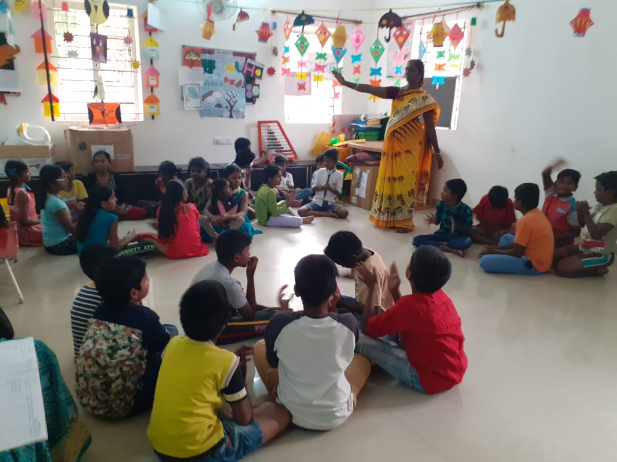
Youth club in progress

- WOMEN’S SAVING IN JEEVANAHALLI
In the financial year 2019-20, 62 women in four savings groups saved Rs. 2,71,700/-.

- WOMEN’S DAY CELEBRATION
Concerns celebrated the women of the community by organizing a Women’s Day celebration in the Janakiram Layout centre. 66 women attended the program. Competitions like Rangoli, Mehendi and Hair styling were conducted along with group games and prizes were distributed. The women were addressed by Dr Daisy Rani Rao and Mrs. Gnana Chitra.

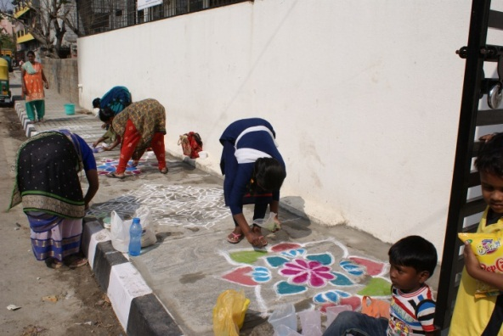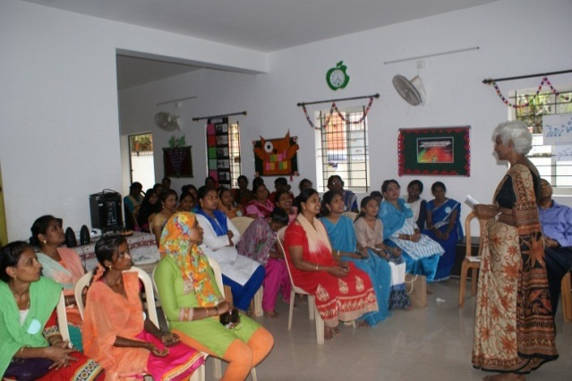
Dr Daisy Rani Rao addressing the community women on Women’s Day

Rangoli Competition

COMMUNITY HEALTH AND DEVELOPMENT PROGRAM CASE STUDIES
- Shwetha (Tuberculosis patient- Janakiram layout)

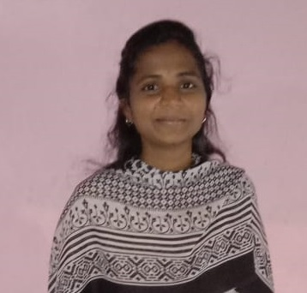
Shwetha is a 21-year-old woman originally from North Karnataka and currently living in a rented house in Janakiram layout. She lives in a joint family with nine members which includes her sister and her younger brother. Shwetha’s sister is diagnosed with bone cancer but works as a tuition teacher to support Shweta and take care of the family. Her parents stay in her native place. Shwetha was pursuing a B.A. Degree in a government college when she turned sick and was admitted to a local hospital and treated for typhoid. She spent all her savings on the treatment. After a month, she felt an increased weakness and no improvement in her condition. Since she had spent all her savings, she did not have money for further tests and treatment. When the Concerns community health team met her, they realised she had all the symptoms for tuberculosis and referred her to the government hospital for the necessary tests where they confirmed the diagnosis. The family found it hard to accept this. Through the community health team’s continuous counselling and follow up, she started treatment in the local RNTCP Dots program. Concerns supported her treatment and provided the necessary nutrition until she completed her treatment. Currently, Shwetha is pursuing her M.A. in Government College and is in good health.

- Varalakshmi (School dropout- Jeevanahalli)

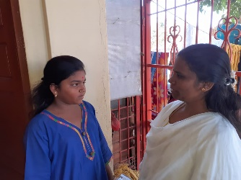
Varalakshmi is a 13-year old whose father works as a painter and mother a housemaid. They lived in a joint family in Jeevanahalli where Varalakshmi was studying in 5th standard in Jeevanahalli Government School (Kannada medium) however because of family issues, they shifted into a rented house in R. S Palaya. As a result, she discontinued her schooling and was at home for three months. Varalakshmi's younger brother Manjunath had to drop out of school as well. The community health team met the family and encouraged them to enrol their children back to school. The family was new to the community and unwilling to send the children to school. It took many visits before the team convinced and motivated the family to send the children back to school. The team went with the family to the school and enrolled Varalakshmi in 5th standard and Manjunath in 3rd standard in Lingarajapuram Government School. The team continuously follows up with the school to monitor their attendance and interact with their class teachers.

GOVERNING BOARD
SL.NO. | NAME | DESIGNATION ON BOARD | AGE | Whether paid a remuneration or not
1 | Mrs. Gnana Chitra | Executive Trustee | 59 | Paid
2 | Mrs. Vasantha Samuel | Treasurer | 69 | Unpaid
3 | Mrs. Rebecca Anbu Thomas | Member Trustee | 44 | Unpaid
4 | Mrs. Santhoshi Lewis | Member Trustee | 42 | Unpaid
DISTRIBUTION OF SALARY
Staff Full-Time | Female- 9 | Male-1
Part-Time | Female- 14 | Male-0
Consultant | Female-1 | Male-0

< Rs. 5,000/- | Female- 9 | Male-
Rs. 5,000/- to Rs. 10,000/- | Female- 10 | Male- 1
Rs. 10,000/- to Rs. 20,000/- | Female- 0 | Male-0
> Rs. 20,000/- | Female- 5 | Male-0
ACCOUNTABILITY
- Concerns Universe Foundation is registered under the Deed of Trust on 11.07.2001 in Karnataka.
- Concerns Universe Foundation is registered under Act 1961 vide register no. DIT (E)/12A/Vol.I/C581/W-1/03-04 Dated. 29.04.2003.
- All contribution to Concern Universe Foundation is Exempted DIT (E) BLR/80G(R)/715/AAAAC1523H/ITO (E)-1/Vol 2009-2010.
- Income Tax Payment Account number on AAAAC1523H.
- Registration under Foreign Contribution (Regulation) Act, 1976. Registration number 094421129.
- Accredited for minimum norms with Credibility Alliance register no. CA/26/2018 valid till 07/10/2023.
OUR SINCERE THANKS TO:
Network for Social Change, UK | Concern India Foundation, Bangalore | Living Hope Community Church, Isle of Man | HI (Help India), UK
Credibility Alliance, Mumbai and New Delhi | Microsoft India Bangalore | Rotary, Manchester Breakfast, UK | Volunteers from overseas and India
National Union of Teachers, Birmingham, UK | Vathsalya Charitable Trust, Bangalore | Mr. Ashok Mollahalli & family USA | Local Government and Private schools
Rotary, Ramsbottom, UK, St. Peter’s Church India Fund, Manchester, UK | Indian Centre for Research and Development of Community Education, Chennai (ICRDCE) | Common Purpose Team Presidency College, Hotel Royal Orchid | Cox Town Dispensary DOTS Centre RNPTC, Bangalore Global Giving
India Share, Manchester,UK | Mrs.Hema Hattangady, Bangalore | International Cultural Youth Exchange (ICYE), Bangalore | ASK Outreach Trust (Action Saves Kids), Isle of Man
CONTACT INFORMATION
Regd: Office Address: No:4, Patel Hanumantha Rayappa Layout, Byrathi Cross, Kothanur Post, Bangalore -560077
Field Office Address: Concerns Community Resource Centre, No: 52, 1st Cross, Balakrishna Road, R.S.Palaya, Bangalore - 560033
Phone Numbers: 080-25475027, 09886720448
Website: https://bit.ly/2LVuIZD
Social Media: Facebook: https://bit.ly/2ZwRrTU; Instagram- https://bit.ly/3girzB6

